**[Day 13 (14th Feb'22) - File Handling](https://learnifyme.ialabs.co.in/course/view.php?id=19" \l "section-13)**

**Khushi Agrawal**

**Java Batch1**

**SESSION 1**

1. create a class and write the information by using File Writer.

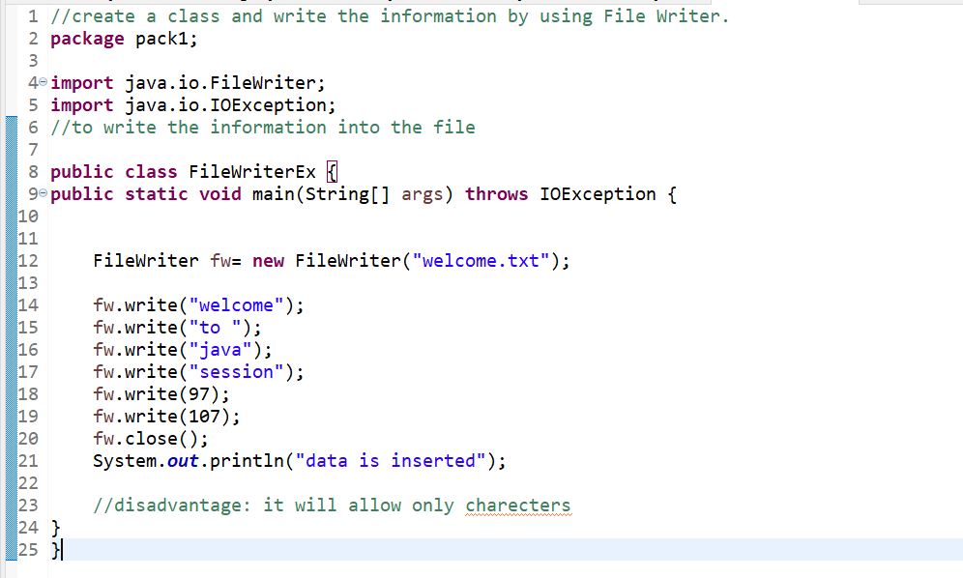

1. create a class and write the information by using Buffered Writer.

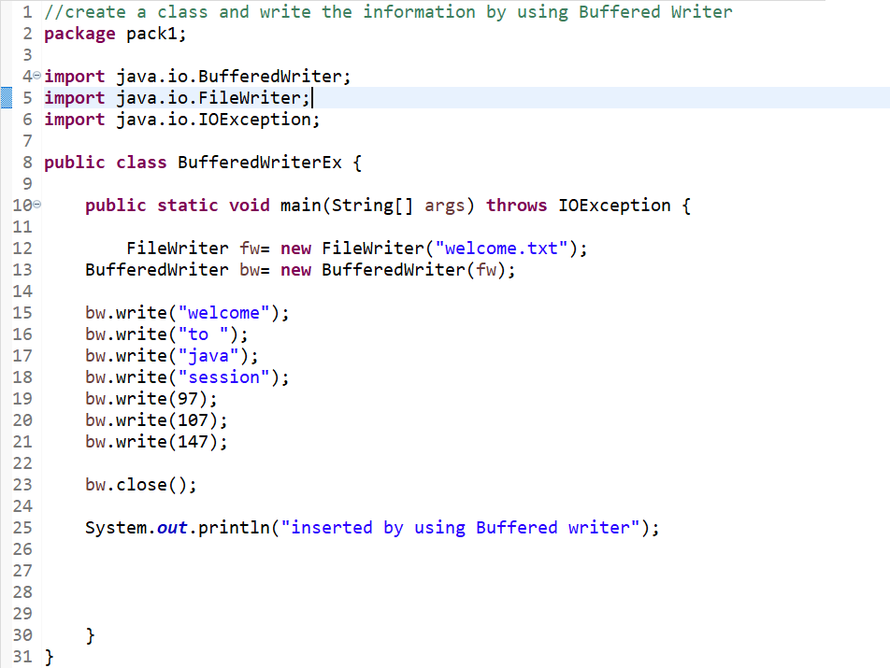

1. create a class and write the information by using Print Writer.

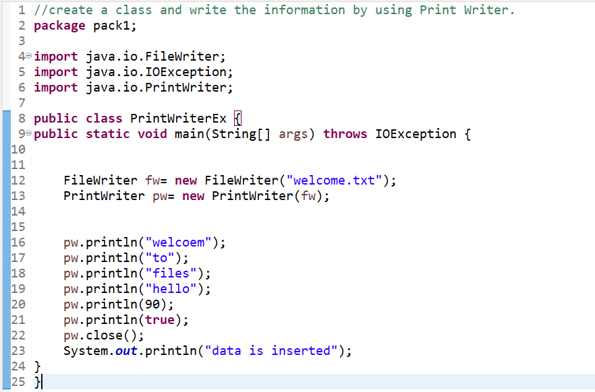

1. create a class and read the information by using File Reader.

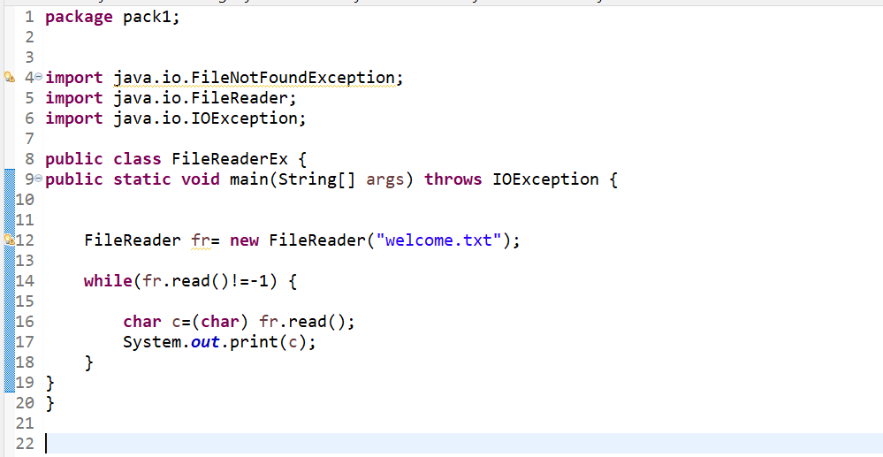

1. create a class and read the information by using Buffered Reader.

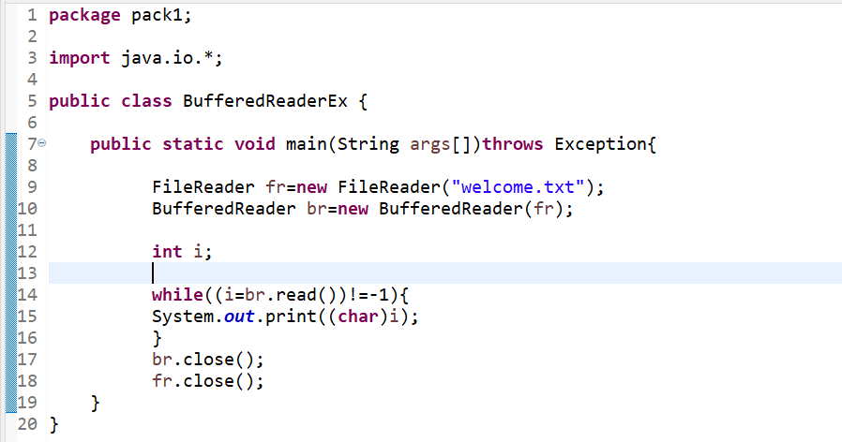

1. Create a class name Demo, create a file.

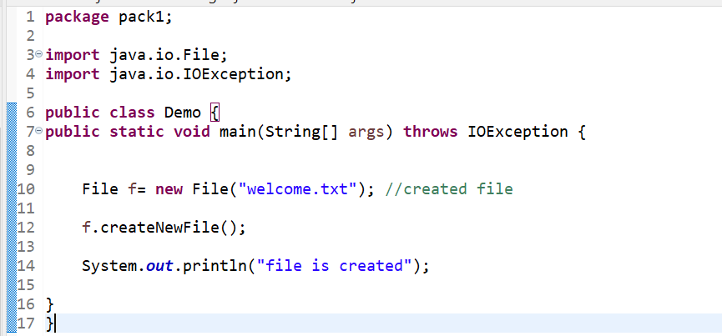

**SESSION 2**

1. create a class ArrayList apply without generics.

